**Blockchain Technology**

**Basic Solidity Smart Contracts – 2**

**Part-1**

**Aim:** Basic Solidity Smart contracts-2 Part-1

1. How to use MetaMask cryptocurrency wallet with Solidity smart contracts.

**Description**:

1. **Solidity** is an object-oriented programming language for implementing smart contracts on various blockchain platforms, most notably, Ethereum.
2. **Remix ide** is used to write and deploy the smart contract.
3. **MetaMask** is a software cryptocurrency wallet used to interact with the Ethereum blockchain. It allows users to access their Ethereum wallet through a browser extension or mobile app, which can then be used to interact with decentralized applications.
4. **Smart contracts** are simply programs stored on a blockchain that run when predetermined conditions are met. They typically are used to automate the execution of an agreement so that all participants can be immediately certain of the outcome, without any intermediary's involvement or time loss.

**Code:**

// SPDX-License-Identifier: UNLICENSED

pragma solidity ^0.8.0;

contract Operations{

    uint num1;

    uint num2;

    function firstNumber(uint a) public{

        num1 = a;

    }

    function secondNumber(uint b) public{

        num2 = b;

    }

    function add() view public returns(uint){

        return num1 + num2;

    }

    function subtract() view public returns(uint){

        return num1 - num2;

    }

    function multiply() view public returns(uint){

        return num1 * num2;

    }

    function divide() view public returns(uint){

        return num1 / num2;

    }

}

**Output:**

Add Metamask extension

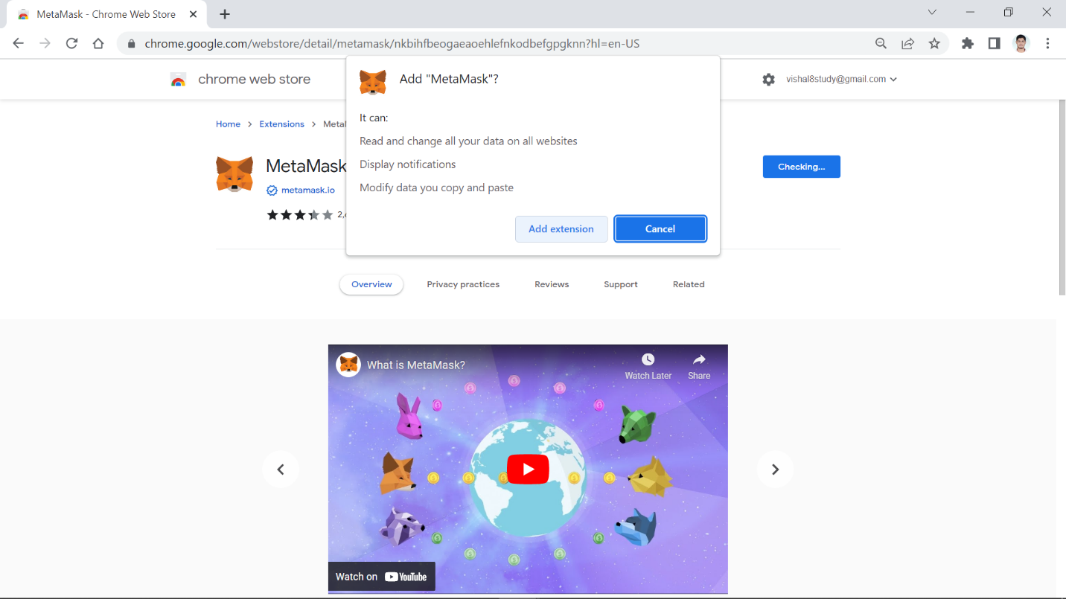

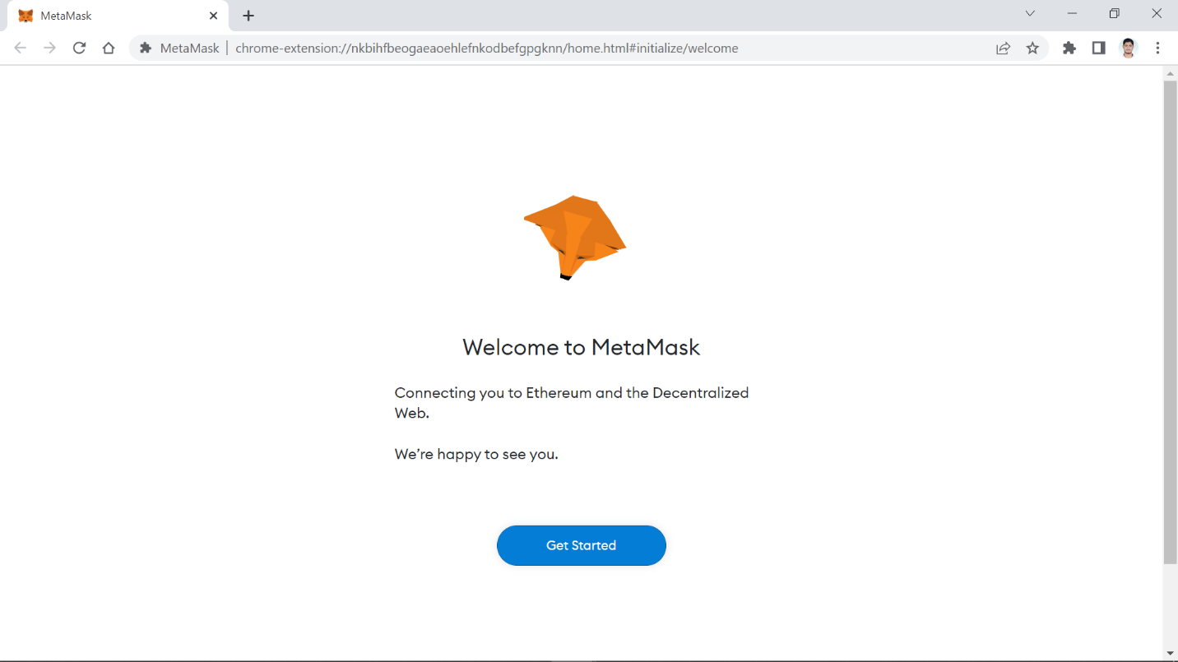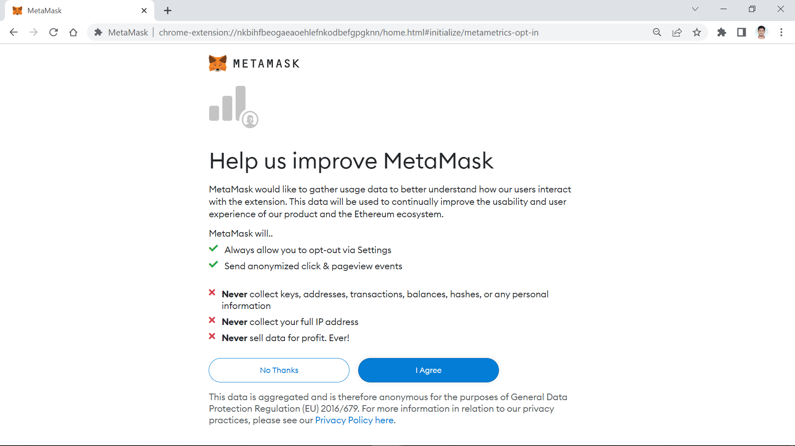s